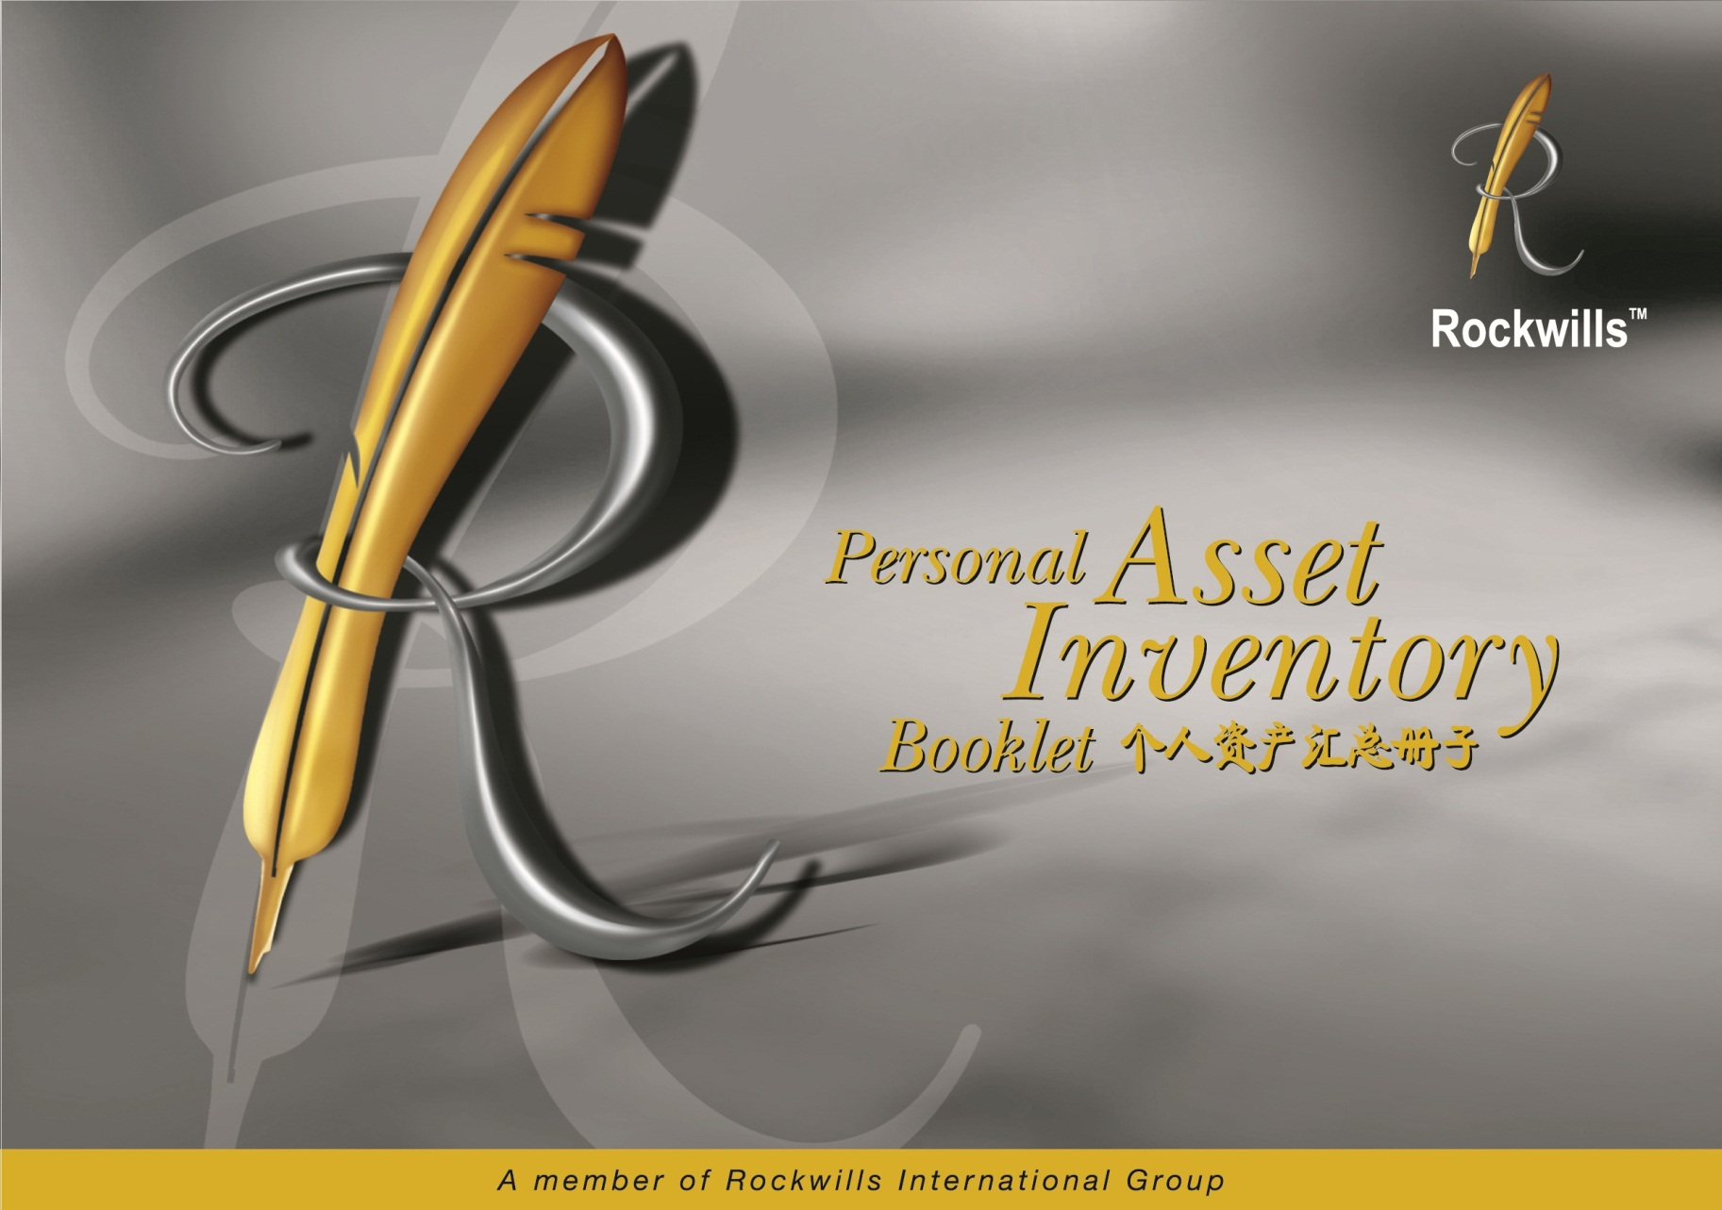

Copyright © 2010 Rockwills Group
No part of this publication may be reproduced, stored in or
introduced into a retrieval system, or transmitted, in any form, or
by any means (electronic, mechanical, photocopying, recording,
or otherwise), without the prior written permission of both
the copyright owner and publisher of this booklet.

版权属乐委集团
在未经版权所有者及出版商的共同许可下，此册子不得以任何形式，任何用途 （电子，机械复印，记录）被翻印，储存或被推介传播与任何其它系统。

CONTENTS 内容
 | Page
Why you must keep your Will safely 为甚么您需要确保安全的遗嘱保管 | 2
Inventory of assets and valuable documents 详细的资产和重要文件记录 | 3
Personal Information 个人资料 | 4
Testamentary Matters 有关遗嘱的资料 | 5
Safe Deposit Box 银行保险箱 | 6
Bank Accounts 银行户口 | 7
Immovable Property 不动产 | 8
Insurance 保险 | 9
Investments / Business 投资 / 生意 | 10
Asset Management 资产管理 | 11
Car 汽车 | 12
Other Assets 其它资产 | 12
Liabilities 负债 | 13
Guarantees 担保 | 13
Special Instructions / Notes 特别指示 / 注明 | 14
Net Estate Valuation 资产净值评估 | 15
Steps in applying for Probate 申请遗嘱认证文件的步骤 | 16
When do I need to rewrite my Will 在甚么情况下需要重写遗嘱 | 17

WHY YOU MUST KEEP YOUR WILL SAFELY 为甚么您要确保安全的遗嘱保管
Making your Will ensures that your last wishes will be fulfilled. However, you should also ensure that your Will can be found when it is needed most by using our professional Will Custody Service. | 立下遗嘱确保您最后的心愿能实现。 除此之外， 通过我们的专业遗嘱保管服务，您就能在最需要的时候找到您的遗嘱。
With your Will in Rockwills safe custody, there is : | 您的遗嘱在安全保管下，将会：
- Peace of mind | - 高枕无忧
- Confidentiality | - 机密
- No hassles and inconvenience | - 免去麻烦和不便
- Protection from tampering | - 保障不会遭人窜改
- Protection from theft | - 保障不会遭人偷窃
- Protection from natural disasters | - 保障免受天灾破坏
- Annual reminder services | - 常年通知服务
- Comprehensive assets inventory system | - 完整的资料存档系统
- Certainty of location | - 肯定被寻获
- Future Will Rewriting Discount* | - 重写遗嘱折扣*
- Free P.A.* | - 免费个人意外保险*

*Subject to terms & conditions *须符合条件

INVENTORY OF ASSETS AND VALUABLE DOCUMENTS 详细的资产和重要文件记录
GENERAL KEY POINTS :  Knowing at all times what personal papers and property(ies) you have – and where they are – is basic to sound personal management. Such a record will help you and your family to realistically plan for the future and to face emergencies with minimum difficulties. If you have yet to catalogue your important papers, now may be the best time to do it.  Furthermore, failure to keep a proper record of all that you possess will lead to delay in the administration of your estate.  The following pages may be of assistance. Fill in the spaces provided where applicable and keep this record of your personal details in a safe but readily accessible place. Once it is completed, you will appreciate the value of keeping such a record.  It is recommended that this record be revised and updated at least once a year.  If you wish to keep this Personal Asset Inventory Booklet (PAIB) in Safe Custody together with your Will, please send it to us following the steps below :-  - Put the PAIB in an envelope and seal it.  - Address to :- |  | 主要重点：  清楚的知道和记录私人的文件和资产及其所在之地是有效资产管理的必要。此记录可以帮助您策划将来以便减轻面对问题出现时所造成的困扰。如果您还没有整理您的文件，现在就是一个良好的时机。  此外，如果没有妥善的记录您所有的产业，在遗嘱管理过程中，将会造成延误。  以下几页将会协助您把私人产业资料一一地列出来。把这本册子保管在安全的地方以便日后可以容易地找到。当您填妥之后，您将会发现此记录的重要性。  我们建议您至少每年检讨及更换这本个人资产汇总册子。  如果您想把这本个人资产汇总册子和您的遗嘱放在一起被保管，请根据下列步骤寄给我们：-  1）把这本个人资产汇总册子放进信封，然后封口。  2）寄至：-
Kuala Lumpur (Head Office) :  Attn : Legal Department (PAIB)  Rockwills Corporation Sdn Bhd  Wisma Rockwills,  No.62, Jalan 2/131A,  Off Jalan Klang Lama,  58200 Kuala Lumpur | Singapore Office :  Attn : Legal Department (PAIB)  Rockwills Corporation Pte Ltd  10 Anson Road,  #28-16, International Plaza,  Singapore 079903 | Kuala Lumpur (Head Office) :  Attn : Legal Department (PAIB)  Rockwills Corporation Sdn Bhd  Wisma Rockwills,  No.62, Jalan 2/131A,  Off Jalan Klang Lama,  58200 Kuala Lumpur | Singapore Office :  Attn : Legal Department (PAIB)  Rockwills Corporation Pte Ltd  10 Anson Road,  #28-16, International Plaza,  Singapore 079903

- Please write your name and Will Registration Code (which is printed on your Rockwills Will Custody Identification Card) on the top left hand side of the envelope. Send to us using Registered mail.  - It is of utmost importance that you keep a copy of the PAIB yourself for reference. If there is insufficient space for any of the items, please attach a separate page.  - If you wish to update your PAIB or review your Will, please do not hesitate to contact your Professional Will-writer, Professional Estate Planner, Franchisee or our office. |  |  | 3）请写上您的姓名和遗嘱号码（遗嘱保管个人身份证明卡上的  编号）在信封的左上角。用挂号邮件寄给我们。  4）请您保存一份副本以便作为日后参考。如果填写的空位不足  够，您可以附加另一页。  5）如果您想要更新您的个人资产汇总册子或检查您的遗嘱，请  联络您的缮写遗嘱专员，遗产规划专员或本公司。
- PERSONAL INFORMATION 个人资料
Full Name 姓名 | :
NRIC / Passport No. 身份证 / 护照号码 | :
Signature used in my Will 遗嘱中使用的签名  (to verify my signature 以鉴定我的签名） | :
Date of completing this PAIB  此个人资产汇总册子的完成日期 | :
Location of Birth Cert. 出生纸存放处 | :

Other items of importance (e.g. Passport, Marriage Certificate)  其它重要文件 （例如护照，结婚证书） | :
EPF / CPF Membership No. 公积金会员编号 | :
EPF / CPF Nominee(s) 公积金被提名者 | :
Income Tax No. 所得税编号 | :
- TESTAMENTARY MATTERS 有关遗嘱的资料
My Will is located at 我的遗嘱存放于 | :
The date of the latest Will is 最新遗嘱的日期 | :
My Professional Will-writer is 我的缮写遗嘱专员是 | :
Contact No. 联络号码 | :
Others 其它 | :
The date of this document is 这份文件的日期是 | :

Executor(s) / Trustee(s) Information 执行人 / 信托人的资料
No.  编号 | Name of Executor / Trustee  执行人 / 信托人 | Address  住址 | Contact Number  联络号码
1
2
3
4
Personal Asset Inventory Booklet 个人资产汇总册子
- SAFE DEPOSIT BOX 银行保险箱
No.  编号 | Bank / Branch  银行/ 分行 | Box Number  保险箱号码 | Key Located At  钥匙存放处
1
2

- BANK ACCOUNTS 银行户口
No.  编号 | Bank / Branch  银行/ 分行 |  |  | Account Type  户口分类 | Account Number  户口号码 |  | Deposit Period  (If Applicable)  存款期间 （如果拥有）
1
2
3
4
5
6
7
8
9
10
LOCATION OF RECORDS 文件存放处 |  | :

- IMMOVABLE PROPERTIES 不动产
No.  编号 | Location / Address  地点 / 地址 | Title No.  地契编号 | Location of  Title Deed  地契存放处
1
2
3
4
5
6
7
8
9
10

- INSURANCE 保险
(For Life Insurance, Group Life Insurance by Employer, Automobile Insurance, Personal Accident Insurance [including those from credit cards], Property Insurance and Health Insurance)
（包括人寿保险，雇主团体人寿保险， 汽车保险， 个人意外保险 [ 包括信用卡]，产业保险和健康保险）
No.  编号 | Insurance Company  保险公司 |  |  | Policy No.  保单编号 | Sum Insured  投保数额 | Nominee(s)  被提名者 | Life Assured  投保人
1
2
3
4
5
6
7
8
9
LOCATION OF POLICIES 保单存放处 |  | :
NAME OF AGENT 保险代理员姓名 |  | :

- INVESTMENT / BUSINESS 投资 / 生意
- LISTED COMPANIES 上市公司
No.  编号 | Brokerage Company  经纪公司 |  | CDS /CDP A/C No.  CDS /CDP 户口号码 | Broker / Contact Number  经纪人 / 联络号码
1
2
3
- NON LISTED COMPANIES / PARTNERSHIP / SOLE-PROPRIETORSHIPS 非上市公司 / 合夥公司 / 个人公司
No.  编号 | Company Name  公司名称 | Location  股票证书 / 文件存放处
1
2
3
4
5

- UNIT TRUSTS 单位信托
No.  编号 | Name of Fund  基金名称 |  | Company Name  公司名称 |  |  | A/C No.  户口号码 |  | Agent  代理
1
2
3
4
- ASSET MANAGEMENT 资产管理
Date 日期 |  | :
No.  编号 | Name of Asset Manager  资产管理经理姓名 |  |  |  | Account No.  户口号码 |  | Contact Person  联络人
1
2
3
4

- CAR 汽车
No.  编号 | Model  款式 | Reg. No  登记号码 |  |  | Year  年度 |  | Registered Name  登记人姓名 | Location of  Registration Card  登记卡存放处
1
2
3
4
- OTHER ASSETS其它资产
No.  编号 | Assets Details  资产资料 |  |  |  |  | Location Details  存放处
1
2
3
4

- LIABILITIES 负债
No.  编号 | Creditor  债权人 |  |  |  | In Respect of  关于 |  | Amount  数目
1
2
3
4
- GUARANTEES 担保人
No.  编号 | Holder  持有人 |  | On Behalf of  代表 |  |  | In Respect of  关于 |  | Amount  数目
1
2
3
4

- SPECIAL INSTRUCTIONS / NOTES 特别指示 / 注明

NET ESTATE VALUATION 资产净值评估
This page is specially designed to help you assess your net estate value. Use the columns provided to list your assets and liabilities.
此页是特别为您而设计的资产评值表。 您可在所提供空格内列出您的资产和债务。
No.  编号 |  | Assets Type  资产的种类 |  |  |  | Gross Value  总额 |  |  |  | No.  编号 | Liability Type  负债的种类 |  |  |  |  | Liability Amount  总额
1 |  | Landed Property 不动产 |  |  |  |  |  |  |  | 1 | Housing Loan 房屋贷款
2 |  | EPF / CPF 公积金 |  |  |  |  |  |  |  | 2 | Overdraft 透资额
3 |  | Insurance 保险 |  |  |  |  |  |  |  | 3 | Car Loan 汽车贷款
4 |  | Listed Shares 上市股票 |  |  |  |  |  |  |  | 4 | Charge / Credit Card 费用 / 信用卡
5 |  | Unit Trust 单位信托 |  |  |  |  |  |  |  | 5 | Personal Loan 个人贷款
6 |  | Cars 汽车 |  |  |  |  |  |  |  | 6 | Income Tax 所得税
 |  | Total Gross Value  资产总额 |  |  |  |  |  |  |  |  | Total Liabilities  负债总额
 |  |  |  |  | Less (-)  减 |  |  |  |  |  |  |  | =
 | (Total Gross Value)  资产总额 |  |  |  |  |  |  |  | (Total Liabilities)  负债总额 |  |  |  |  |  | (Net Estate Value)  净值

STEPS IN APPLYING FOR PROBATE 申请遗嘱认证文件的步骤
Rockwills Trustee Bhd applies for Probate/Executor refers to a Lawyer to apply for Probate
To Get Started
Obtain the Original Death Certificate
Rockwills Trustee Bhd / Executor retrieves the Will from Rockwills
Prepare an inventory of Testator’s assets using this booklet (PAIB)
Petition for Probate
- Fill in Form 168 (Rules of High Court)
- Executor to verify by oath
- Certified true copy of Will
- Interpretation of Will
(if not in English/Bahasa Malaysia)
- If more than 3 years after death of
Testator – affidavit for delay
Probate granted
Rockwills Trustee Bhd/Executor to extract Probate
- Collect all assets
- Pay debts including income tax of Testator
Distribution by Rockwills Trustee Bhd/Executor
- Movable : delivery to beneficiary
- Immovable : transmit by deed to Executor and vesting
From Rockwills Trustee Bhd/Executor to Beneficiary

Please note that the contents represent only a brief outline of the steps to be taken to obtain Grant of Probate

WHEN DO I NEED TO REWRITE MY WILL 在甚么情况下需要重谢遗嘱？
Consult your Professional Will Writer/Estate Planner should any of the following events occur : | 如果发生以下的事件，请联络您的缮写遗嘱专员 / 资产规划专员：
- the death of an intended executor or change of executor; | - 预定的遗嘱执行人逝世或更改遗嘱执行人；
- there is substantial change in your financial situation; | - 您的财产状况发生重大的改变；
- the death of an intended beneficiary; | - 预定的遗嘱受益人逝世；
- a new arrival in the family; | - 新家庭成员的诞生；
- you separate from or divorce your spouse; | - 和您的配偶分居或离婚；
- you remarry; | - 重婚；
- you enter into a de facto relationship; | - 同居；
- there is a change in legislation such as death duties; | - 立法的改变比如死亡所须负的责任；
- the death of both witnesses of the Will or difficult to locate both witnesses or if they migrate to another country; | - 两位遗嘱见证人已逝世或无法联络或他们已移民至另一个国家；
- you intend to reallocate your assets to your beneficiaries; | - 您计划重新分配您的资产于受益人。
- you intend to set up a Trust fund for your beneficiaries | - 您计划设立信托基金于受益人。

ADDITIONAL NOTES :

ADDITIONAL NOTES :

ADDITIONAL NOTES :

ROCKWILLS INTERNATIONAL GROUP OF COMPANIES
MALAYSIA  Rockwills Corporation Sdn. Bhd.  (274516-K)  HEAD OFFICE :  Wisma Rockwills, No.62, Jalan 2/131A,  Off Jalan Klang Lama, 58200 Kuala Lumpur  Tel : 03-7781 1993 Fax : 03-7781 2993  E-mail : general@rockwills.com  Website : www.rockwills.com  Rockwills Business Solutions Sdn. Bhd.  (626253-U)  Wisma Rockwills, No.62, Jalan 2/131A,  Off Jalan Klang Lama, 58200 Kuala Lumpur  Tel : 03-7781 1993 Fax : 03-7781 9119  E-mail : rbs@rockwills.com  Website : www.rockwills.com  Rockwills Trustee Berhad  (708932-T)  Wisma Rockwills, No.62, Jalan 2/131A,  Off Jalan Klang Lama, 58200 Kuala Lumpur  Tel : 03-7781 1993 Fax : 03-7783 2993  E-mail : trustee@rockwills.com  Website : www.rockwills.com  Rockwills Wealth Planner Sdn. Bhd.  (556666-T)  Wisma Rockwills, No.62, Jalan 2/131A,  Off Jalan Klang Lama, 58200 Kuala Lumpur  Tel : 03-7781 1993 Fax : 03-7781 2993  E-mail : general@rockwills.com  Website : www.rockwills.com  Rockwills Properties Sdn. Bhd.  (717456-K)  Wisma Rockwills, No.62, Jalan 2/131A,  Off Jalan Klang Lama, 58200 Kuala Lumpur  Tel : 03-7781 1993 Fax : 03-7781 2993  E-mail : general@rockwills.com | MALAYSIA  REGIONAL OFFICES :  Rockwills Penang  A-2-1, Lorong Bayan Indah 4,  Bay Avenue, Bayan Lepas,  11900 Penang  Tel : 04-643 7993 Fax : 04-642 0993  Rockwills Johor Bahru  No.93-3, Jalan Molek 3/10, Taman Molek,  81100 Johor Bahru, Johor  Tel : 07-355 3033 Fax : 07-355 2033  Rockwills Kota Kinabalu  1st Floor, Unit No.8, Block A, Heritage Plaza,  88300 Kota Kinabalu, Sabah  Tel : 088-722 192 Fax : 088-721 192  Rockwills Kuching  Section 64, 1st Floor Lot 4370 & 4403,  Sub Lot 19, LTKD,  Panovel Commercial Centre,  Jalan Simpang Tiga,  93300 Kuching, Sarawak  Tel/Fax : 082-256 993  AFFILIATED COMPANY  as-Salihin Trustee Berhad  (670367-D)  101 & 201, Block A, Glomac Business Centre,  No.10, Jalan SS 6/1, Kelana Jaya,  47301 Petaling Jaya, Selangor,  Tel : 03-7880 9595 Fax : 03-7880 8190  E-mail : general@as-salihin.com  Website : www.as-salihin.com | SINGAPORE  Rockwills International Pte Ltd  (200803829R)  10 Anson Road, #28-16,  International Plaza, Singapore 079903  Tel : (65) 6221 8633 Fax : (65) 6538 1362  E-mail : email@rockwills.com  Website : www.rockwills.com  Rockwills Corporation Pte Ltd  (199704239Z)  10 Anson Road, #28-16,  International Plaza, Singapore 079903  Tel : (65) 6221 8633 Fax : (65) 6538 1362  E-mail : email@rockwills.com  Website : www.rockwills.com  Rockwills Trustee Ltd  (200806001K)  10 Anson Road, #28-16,  International Plaza, Singapore 079903  Tel : (65) 6221 8633 Fax : (65) 6538 1362  E-mail : email@rockwills.com  Website : www.rockwills.com  Rockwills Corporate Services Pte Ltd  (200803839H)  10 Anson Road, #28-16,  International Plaza, Singapore 079903  Tel : (65) 6221 8633 Fax : (65) 6538 1362  E-mail : email@rockwills.com  Website : www.rockwills.com

